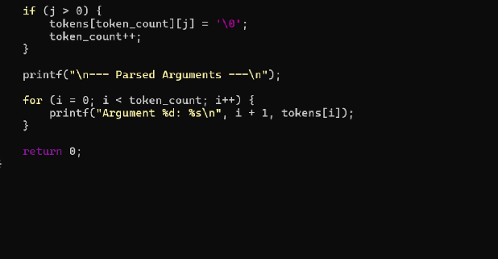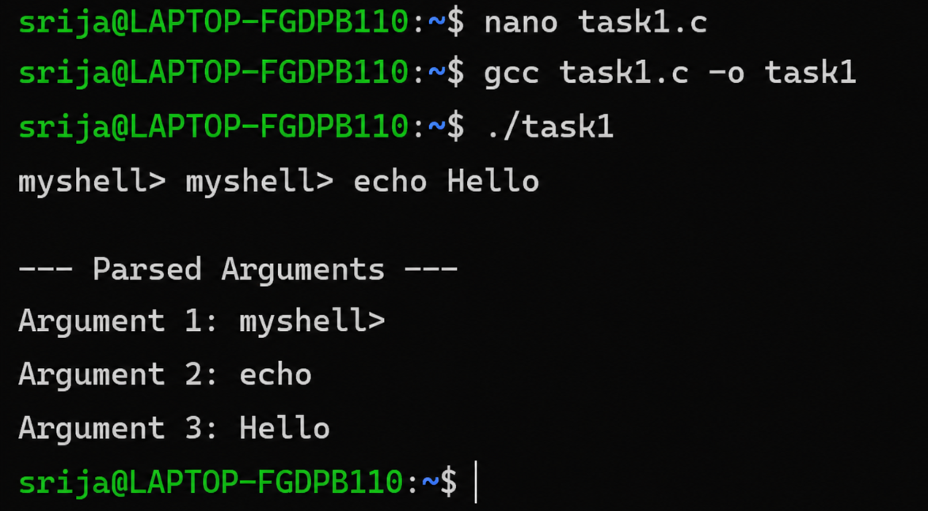
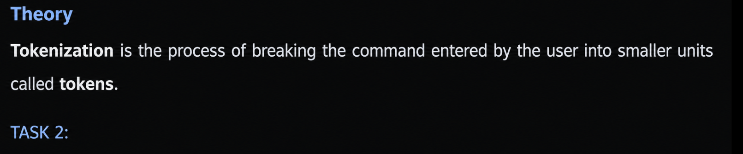
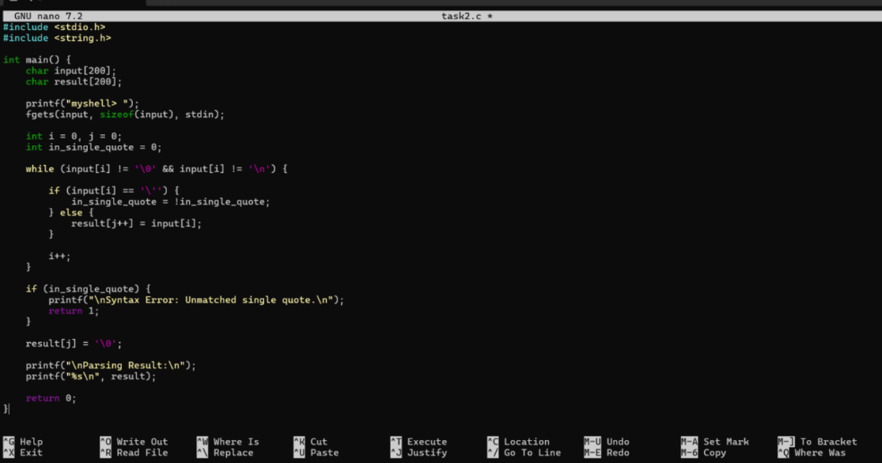
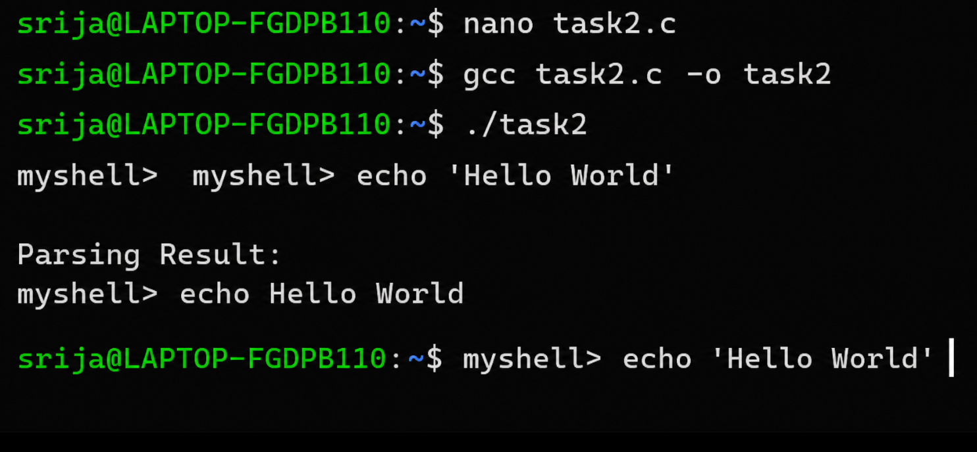
Theory :
Single quotes are used to prevent the literal content inside them .
Task 3 :
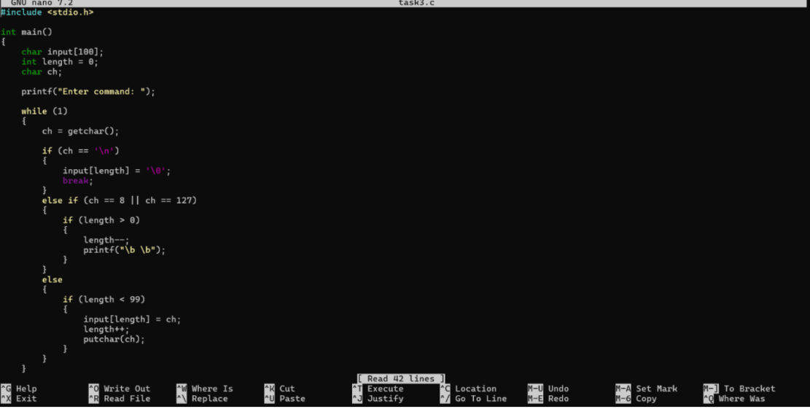
Theory :
Double quotes allow spaces to remain part of the same argument while still allowing variable expansion
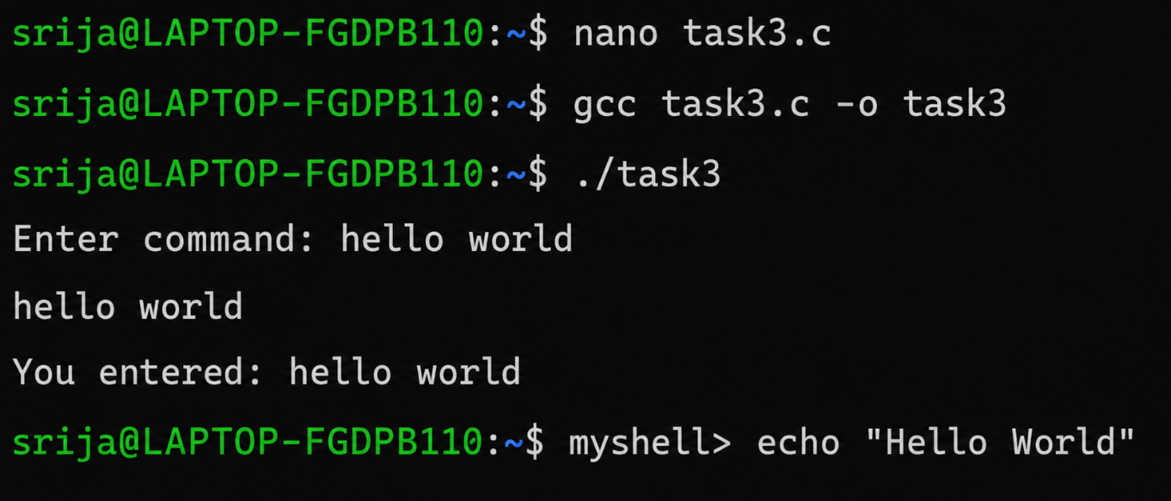

Theory :
Double quotes allow spaces to remain part of the same argument while still allowing variable expansion
Task 4:
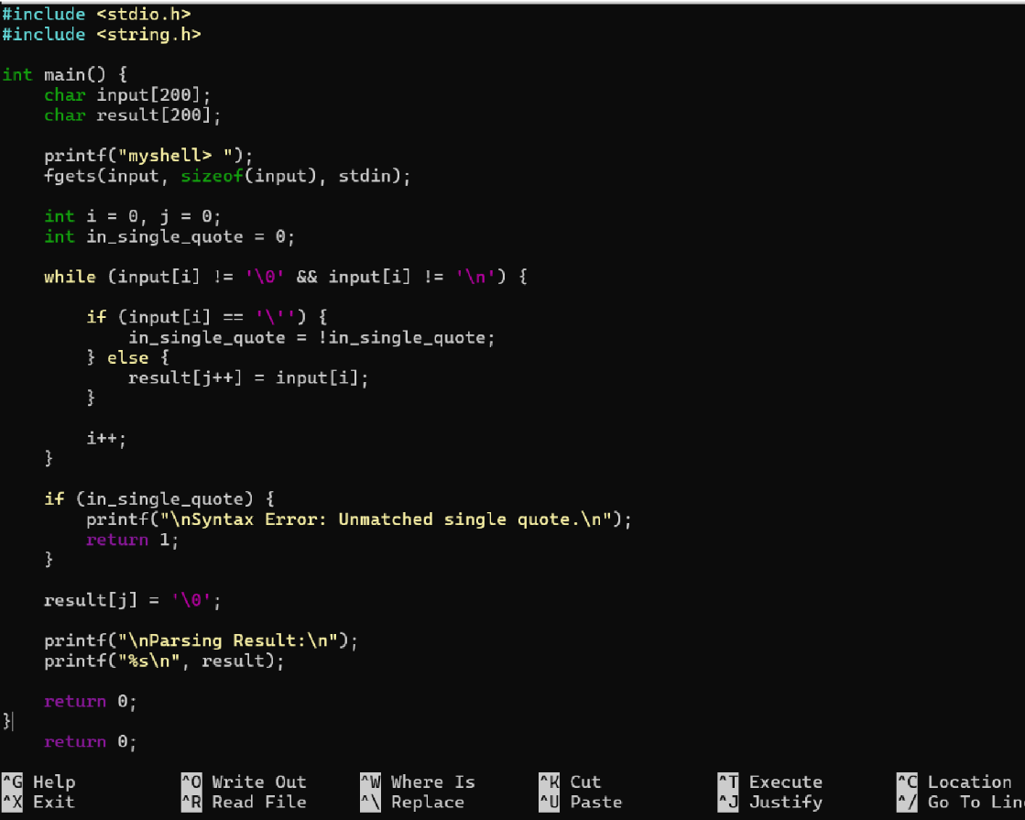
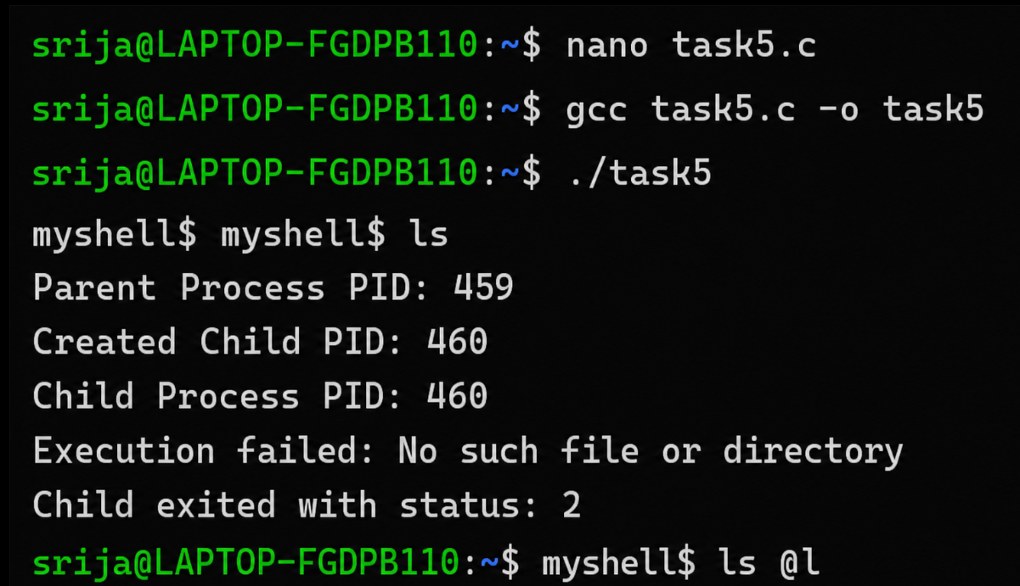
Task 5 is about creating and managing child processes. A parent process creates a child process using fork(). The child process executes the required program using execvp(), while the parent process waits for the child to finish using waitpid().
The program also passes arguments to the child process and handles execution errors if the command cannot be run.

